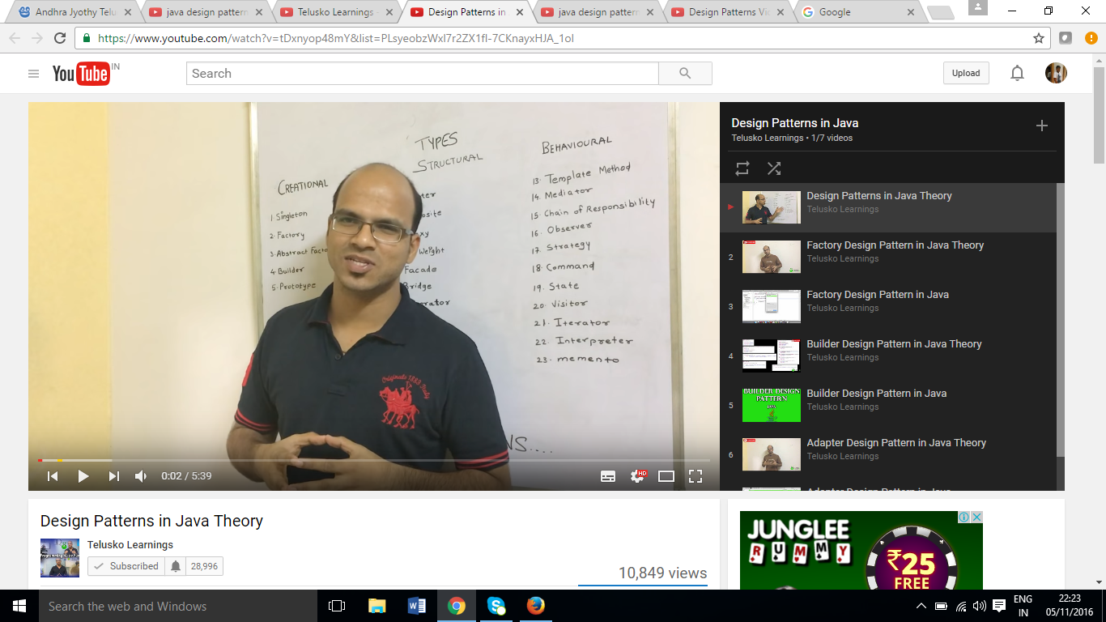

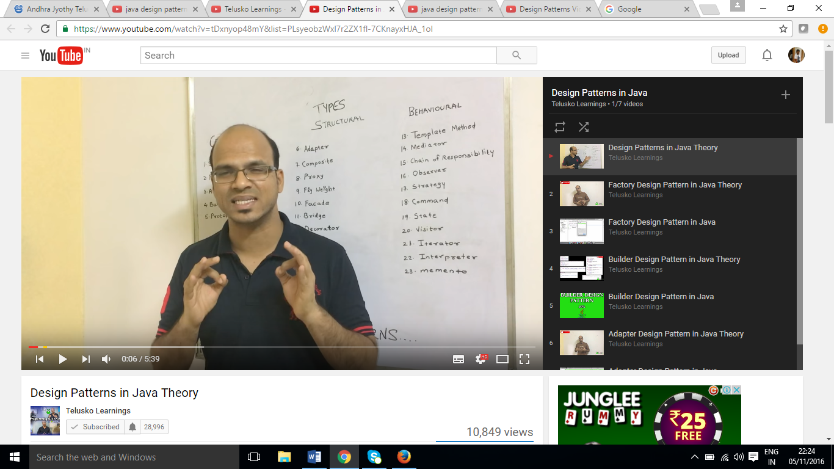

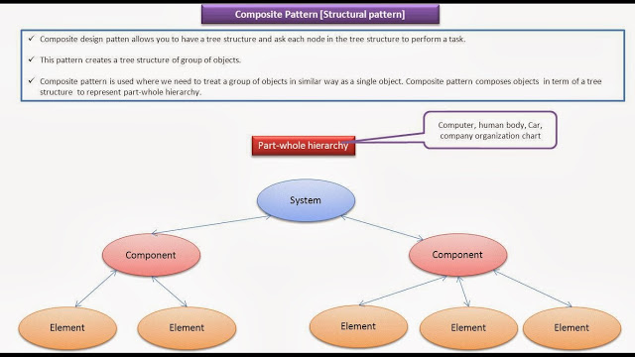

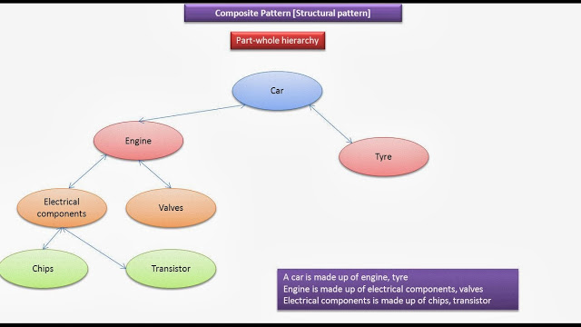

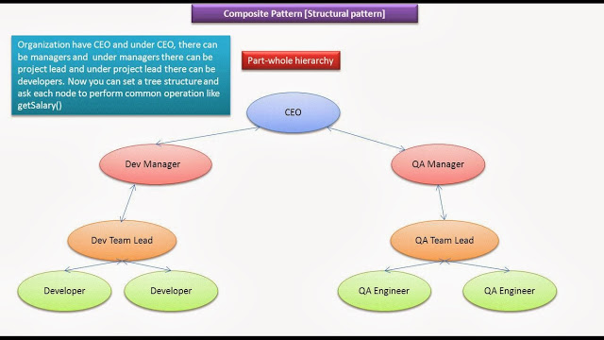
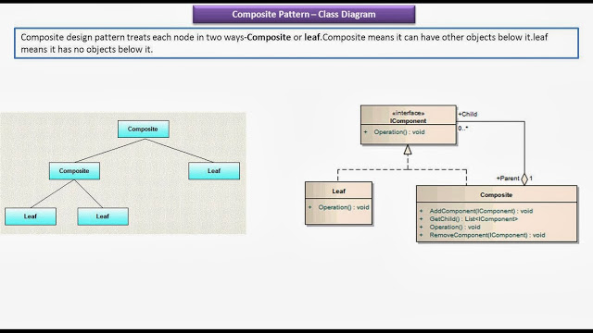

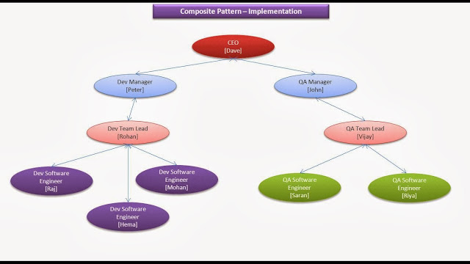

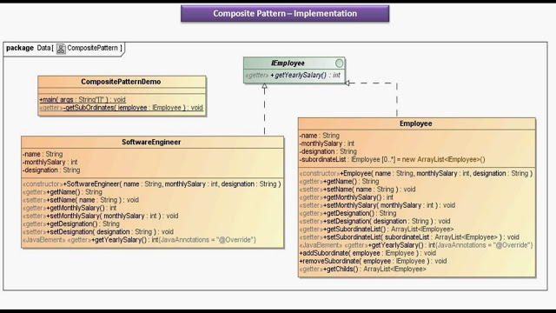

yee.java

public interface IEmployee
{
public int getYearlySalary();

}

Employee.java

import java.util.ArrayList;

// Employee class is the Composite node [i.e. it can have other objects below it]

public class Employee implements IEmployee
{

private String name;
private int monthlySalary;

// Employee designation Can be CEO,Dev Manager,QA Manager,Dev TeamLead,QA TeamLead

private String designation;

private ArrayList<IEmployee> subordinateList = new ArrayList<IEmployee>();

public Employee( String name, int monthlySalary, String designation )
{
super();
this.name = name;
this.monthlySalary = monthlySalary;
this.designation = designation;
}

public String getName()
{
return name;
}

public void setName( String name )
{
this.name = name;
}

public int getMonthlySalary()
{
return monthlySalary;
}

public void setMonthlySalary( int monthlySalary )
{
this.monthlySalary = monthlySalary;
}

public String getDesignation()
{
return designation;
}

public void setDesignation( String designation )
{
this.designation = designation;
}

public ArrayList<IEmployee> getSubordinateList()
{
return subordinateList;
}

public void setSubordinateList( ArrayList<IEmployee> subordinateList )
{
this.subordinateList = subordinateList;
}

@Override
public int getYearlySalary()
{
return monthlySalary * 12;
}

public void addSubordinate( IEmployee employee )
{
subordinateList.add(employee);
}

public void removeSubordinate( IEmployee employee )
{
subordinateList.remove(employee);
}

public ArrayList<IEmployee> getChilds()
{
return getSubordinateList();
}

}

SoftwareEngineer.java

// SoftwareEngineer class is the Leaf node [i.e. it cann't have other objects below it]

public class SoftwareEngineer implements IEmployee
{
private String name;
private int monthlySalary;

// Employee designation Can be Dev Software Engineer, QA Software Engineer
private String designation;

public SoftwareEngineer( String name, int monthlySalary, String designation )
{
super();
this.name = name;
this.monthlySalary = monthlySalary;
this.designation = designation;
}

public String getName()
{
return name;
}

public void setName( String name )
{
this.name = name;
}

public int getMonthlySalary()
{
return monthlySalary;
}

public void setMonthlySalary( int monthlySalary )
{
this.monthlySalary = monthlySalary;
}

public String getDesignation()
{
return designation;
}

public void setDesignation( String designation )
{
this.designation = designation;
}

@Override
public int getYearlySalary()
{
return monthlySalary * 12;
}

}

CompositePatternDemo.java

import java.util.ArrayList;

public class CompositePatternDemo
{

public static void main( String[] args )
{
Employee dave = new Employee("Dave", 200000, "CEO");

Employee peter = new Employee("peter", 100000, "Dev Manager");
Employee john = new Employee("John", 100000, "QA Manager");

Employee rohan = new Employee("Rohan", 50000, "Dev TeamLead");
Employee vijay = new Employee("Vijay", 50000, "QA TeamLead");

SoftwareEngineer raj = new SoftwareEngineer("Raj", 30000, "Dev Software Engineer");
SoftwareEngineer mohan = new SoftwareEngineer("Mohan", 30000, "Dev Software Engineer");
SoftwareEngineer hema = new SoftwareEngineer("Hema", 30000, "Dev Software Engineer");

SoftwareEngineer saran = new SoftwareEngineer("Saran", 20000, "QA Software Engineer");
SoftwareEngineer riya = new SoftwareEngineer("Riya", 20000, "QA Software Engineer");

dave.addSubordinate(peter);
dave.addSubordinate(john);

peter.addSubordinate(rohan);
john.addSubordinate(vijay);

rohan.addSubordinate(raj);
rohan.addSubordinate(mohan);
rohan.addSubordinate(hema);

vijay.addSubordinate(saran);
vijay.addSubordinate(riya);

getSubOrdinates(dave);
getSubOrdinates(peter);
getSubOrdinates(john);
getSubOrdinates(rohan);
getSubOrdinates(vijay);
getSubOrdinates(raj);
getSubOrdinates(mohan);
getSubOrdinates(hema);
getSubOrdinates(saran);
getSubOrdinates(riya);
}

private static void getSubOrdinates( IEmployee iemployee )
{
if( iemployee instanceof Employee )
{
Employee employee = (Employee) iemployee;
System.out.println("\n------------- SubordinatesListOf "+ employee.getName() +" : "+employee.getDesignation() + " ---------------------------------\n");
ArrayList<IEmployee> subordinatesListOfDave = employee.getChilds();
for( IEmployee iEmployee : subordinatesListOfDave )
{
if( iEmployee instanceof Employee )
{
Employee employeeObj = (Employee) iEmployee;
System.out.println(employeeObj.getName() + " : " + employeeObj.getDesignation() + ":"
+ employeeObj.getMonthlySalary() + ":" + employeeObj.getYearlySalary());
}
else
{
SoftwareEngineer softwareEngineer = (SoftwareEngineer) iEmployee;
System.out.println(softwareEngineer.getName() + " : "
+ softwareEngineer.getDesignation() + ":"
+ softwareEngineer.getMonthlySalary() + ":"
+ softwareEngineer.getYearlySalary());

}

}
}
else
{
System.out.println("\n--------------------------------------------------------------------------------------");
SoftwareEngineer softwareEngineer = (SoftwareEngineer) iemployee;
System.out.println("\nNo Subordinates for "+softwareEngineer.getName()+" : "+softwareEngineer.getDesignation()
+" : "+softwareEngineer.getMonthlySalary()+" : "+softwareEngineer.getYearlySalary());
}

}

}

Output

------------- SubordinatesListOf Dave : CEO ---------------------------------

peter : Dev Manager:100000:1200000
John : QA Manager:100000:1200000

------------- SubordinatesListOf peter : Dev Manager ---------------------------------

Rohan : Dev TeamLead:50000:600000

------------- SubordinatesListOf John : QA Manager ---------------------------------

Vijay : QA TeamLead:50000:600000

------------- SubordinatesListOf Rohan : Dev TeamLead ---------------------------------

Raj : Dev Software Engineer:30000:360000
Mohan : Dev Software Engineer:30000:360000
Hema : Dev Software Engineer:30000:360000

------------- SubordinatesListOf Vijay : QA TeamLead ---------------------------------

Saran : QA Software Engineer:20000:240000
Riya : QA Software Engineer:20000:240000

--------------------------------------------------------------------------------------

No Subordinates for Raj : Dev Software Engineer : 30000 : 360000

--------------------------------------------------------------------------------------

No Subordinates for Mohan : Dev Software Engineer : 30000 : 360000

--------------------------------------------------------------------------------------

No Subordinates for Hema : Dev Software Engineer : 30000 : 360000

--------------------------------------------------------------------------------------

No Subordinates for Saran : QA Software Engineer : 20000 : 240000

--------------------------------------------------------------------------------------

No Subordinates for Riya : QA Software Engineer : 20000 : 240000

https://dzone.com/articles/composite-design-pattern-java-0

Composite Design Pattern in Java
 by
Arpit Mandliya
·
Feb. 18, 13 · Java Zone
Like (0)

Comment (3)

Save

Tweet
40.90k Views
Join the DZone community and get the full member experience.
JOIN FOR FREE
Learn more about the advantages of moving from a monolithic to microservices architecture. Brought to you in partnership with IBM.
Composite design patten allows you to have a tree structure and ask each node in the tree structure to perform a task.You can take real life example of a organization.It have general managers and under general managers, there can be managers and under managers there can be developers.Now you can set a tree structure and ask each node to perform common operation like getSalary().
As described by Gof:
"Compose objects into tree structure to represent part-whole hierarchies.Composite lets client treat individual objects and compositions of objects uniformly".
Composite design pattern treats each node in two ways-Composite or leaf.Composite means it can have other objects below it.leaf means it has no objects below it.
Tree structure:
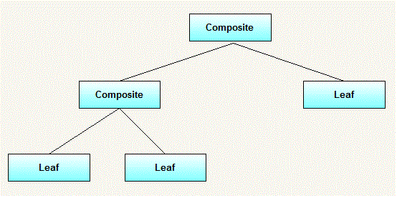

When to use it:
- you want to represent part-whole hierachies of objects.
- you want client to be able to ignore difference between compositions of objects and individual objects.Clients will treat all objects in the composite structure uniformly.

UML Diagram for Composite design pattern:
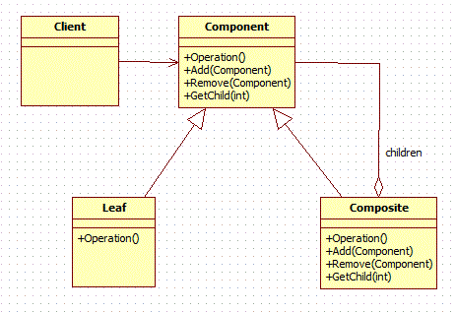

Elements:
- Component
  - declares interface for objects in composition.
  - implements deafault behaviour for the interface common to all classes as appropriate.
  - declares an interface for accessing and managing its child components.
- Leaf
  - represents leaf objects in the composition.A leaf has no children.
  - defines behaviour for primitive objects in the composition.
- Composite
  - defines behaviour for components having children.
  - stores child components.
  - implements child related operations in the component interface.
- Client
  - manipulates objects in the composition through the component interface.

WorkFlow:
Client use the component class interface to interact with objects in the composition structure.if recipient is a leaf then request is handled directly.If recipient is a composite,then it usually forwards request to its child components,possibly performing additional operations before and after forwarding.

Recursion:
What makes the Composite pattern one of the most beautiful is the power of recursion. I can explain this with the same organization example. You want to find the total salary paid to all employees of the organization. It is nothing but the salary of CEO + the salary paid to all the departments. What is the salary of a department? It is the salary of the department head + the salary of all projects. What is the total salary of a project? It is the salary of the project manager + the salary of all the project members. In short, the salary of anything is the salary of self + the salary of all its sub groups.

Example:
In a small organization,there are 5 employees.At top position,there is 1 general manager.Under general manager,there are two employees,one is manager and other is developer and further manager has two developers working under him.We want to print name and salary of all employees from top to bottom.
Tree structure for example:
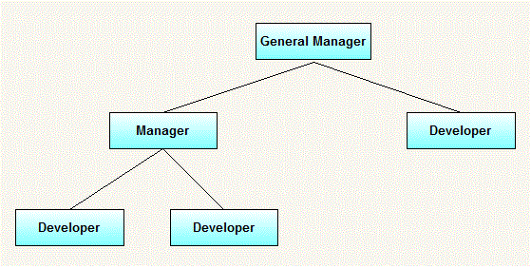
UML diagram for above example:
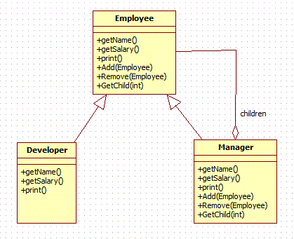
Comparing from above generic elements.Our example consist of following elements.
- Manager(Composite)
- Developer(Leaf)
- Employee(Component)

Java code for all above classes:
First we will create component inrteface.It represents object in composition .It has all common operation that will be applicable to both manager and developer.
Employee.java(Component) :
package org.arpit.javapostsforlearning.designpatterns;

public interface Employee {

public void add(Employee employee);
public void remove(Employee employee);
public Employee getChild(int i);
public String getName();
public double getSalary();
public void print();
}

Now we will create manager(composite class).Key point here is that all common method delegates its operations to child objects.It has method to access and modify its children.
Manager.java(Composite):
package org.arpit.javapostsforlearning.designpatterns;

import java.util.ArrayList;
import java.util.Iterator;
import java.util.List;

public class Manager implements Employee{

private String name;
private double salary;

public Manager(String name,double salary){
this.name = name;
this.salary = salary;
}

List<Employee> employees = new ArrayList<Employee>();
public void add(Employee employee) {
employees.add(employee);
}

public Employee getChild(int i) {
return employees.get(i);
}

public String getName() {
return name;
}

public double getSalary() {
return salary;
}

public void print() {
System.out.println("-------------");
System.out.println("Name ="+getName());
System.out.println("Salary ="+getSalary());
System.out.println("-------------");

Iterator<Employee> employeeIterator = employees.iterator();
while(employeeIterator.hasNext()){
Employee employee = employeeIterator.next();
employee.print();
}
}

public void remove(Employee employee) {
employees.remove(employee);
}

}
We will create developer class.This class is leaf node so all operations related to accessing children will be empty as it has no children.
Developer.java(Leaf):

package org.arpit.javapostsforlearning.designpatterns;
/**
* In this class,there are many methods which are not applicable to developer because
* it is a leaf node.
*/

public class Developer implements Employee{

private String name;
private double salary;

public Developer(String name,double salary){
this.name = name;
this.salary = salary;
}
public void add(Employee employee) {
//this is leaf node so this method is not applicable to this class.
}

public Employee getChild(int i) {
//this is leaf node so this method is not applicable to this class.
return null;
}

public String getName() {
return name;
}

public double getSalary() {
return salary;
}

public void print() {
System.out.println("-------------");
System.out.println("Name ="+getName());
System.out.println("Salary ="+getSalary());
System.out.println("-------------");
}

public void remove(Employee employee) {
//this is leaf node so this method is not applicable to this class.
}

}
CompositeDesignPatternMain.java:
package org.arpit.javapostsforlearning.designpatterns;

public class CompositeDesignPatternMain {

public static void main(String[] args) {
Employee emp1=new Developer("John", 10000);
Employee emp2=new Developer("David", 15000);
Employee manager1=new Manager("Daniel",25000);
manager1.add(emp1);
manager1.add(emp2);
Employee emp3=new Developer("Michael", 20000);
Manager generalManager=new Manager("Mark", 50000);
generalManager.add(emp3);
generalManager.add(manager1);
generalManager.print();
}
}

Output:
-------------
Name =Mark
Salary =50000.0
-------------
-------------
Name =Michael
Salary =20000.0
-------------
-------------
Name =Daniel
Salary =25000.0
-------------
-------------
Name =John
Salary =10000.0
-------------
-------------
Name =David
Salary =15000.0
-------------

Disadvantages:
- Once tree structure is defined,comosite design makes tree overly general.
- Leaf class have to create some methods which has to empty.

Usage in JDK:
- java.util.Map#putAll(Map)
- java.util.List#addAll(Collection)
- java.util.Set#addAll(Collection)
- java.nio.ByteBuffer#put(ByteBuffer) (also on CharBuffer, ShortBuffer, IntBuffer, LongBuffer, FloatBuffer and DoubleBuffer)
- java.awt.Container#add(Component)

Composite Pattern
- Composite Design Pattern
- Advantage of Composite DP
- Usage of Composite DP
- UML of Composite DP
- Example of Composite DP
A Composite Pattern says that just "allow clients to operate in generic manner on objects that may or may not represent a hierarchy of objects".

Advantage of Composite Design Pattern
- It defines class hierarchies that contain primitive and complex objects.
- It makes easier to you to add new kinds of components.
- It provides flexibility of structure with manageable class or interface.

Usage of Composite Pattern
It is used:
- When you want to represent a full or partial hierarchy of objects.
- When the responsibilities are needed to be added dynamically to the individual objects without affecting other objects. Where the responsibility of object may vary from time to time.

UML for Composite Pattern
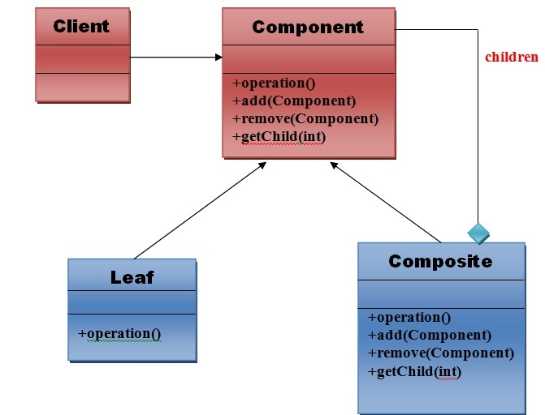

Elements used in Composite Pattern:
Let's see the 4 elements of composte pattern.

1) Component
- Declares interface for objects in composition.
- Implements default behavior for the interface common to all classes as appropriate.
- Declares an interface for accessing and managing its child components.

2) Leaf
- Represents leaf objects in composition. A leaf has no children.
- Defines behavior for primitive objects in the composition.

3) Composite
- Defines behavior for components having children.
- Stores child component.
- Implements child related operations in the component interface.

4) Client
- Manipulates objects in the composition through the component interface.

Note:The work flow of above general UML is as follows.
Client uses the component class interface to interact with objects in the composition structure. If recipient is the leaf then request will be handled directly. If recipient is a composite, then it usually forwards the request to its child for performing the additional operations.

Example of Composite Pattern
We can easily understand the example of composite design pattern by the UML diagram given below:

Composite Design Pattern
When we want to represent part-whole hierarchy, use tree structure and compose objects. We know tree structure what a tree structure is and some of us don’t know what a part-whole hierarchy is. A system consists of subsystems or components. Components can further be divided into smaller components. Further smaller components can be divided into smaller elements. This is a part-whole hierarchy.
Everything around us can be a candidate for part-whole hierarchy. Human body, a car, a computer, lego structure, etc. A car is made up of engine, tyre, … Engine is made up of electrical components, valves, … Electrical components is made up of chips, transistor, … Like this a component is part of a whole system. This hierarchy can be represented as a tree structure using composite design pattern.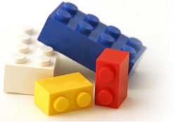
“Compose objects into tree structures to represent part-whole hierarchies. Composite lets clients treat individual objects and compositions of objects uniformly.” is the intent by GoF.

Real World Example
In this article, let us take a real world example of part-whole hierarchy and use composite design pattern using java. As a kid, I have spent huge amount of time with lego building blocks. Last week I bought my son an assorted kit lego and we spent the whole weekend together building structures.
Let us consider the game of building blocks to practice composite pattern. Assume that our kit has only three unique pieces ( 1, 2 and 4 blocks) and let us call these as primitive blocks as they will be the end nodes in the tree structure. Objective is to build a house and it will be a step by step process. First using primitive blocks, we should construct multiple windows, doors, walls, floor and let us call these structures. Then use all these structure to create a house.
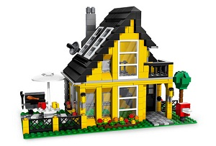
Primitive blocks combined together gives a structure. Multiple structures assembled together gives a house.

Important Points
- Importance of composite pattern is, the group of objects should be treated similarly as a single object.
- Manipulating a single object should be as similar to manipulating a group of objects. In sync with our example, we join primitive blocks to create structures and similarly join structures to create house.
- Recursive formation and tree structure for composite should be noted.
- Clients access the whole hierarchy through the components and they are not aware about if they are dealing with leaf or composites.

Tree for Composite
When we get a recursive structure the obvious choice for implementation is a tree. In composite design pattern, the part-whole hierarchy can be represented as a tree. Leaves (end nodes) of a tree being the primitive elements and the tree being the composite structure.
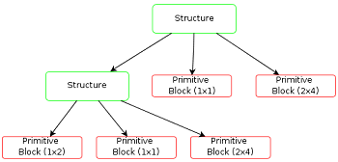

Uml Design for Composite Pattern
Component: (structure)
- Component is at the top of hierarchy. It is an abstraction for the composite.
- It declares the interface for objects in composition.
- (optional) defines an interface for accessing a component’s parent in the recursive structure, and implements it if that’s appropriate.
Leaf: (primitive blocks)
- The end nodes of the tree and will not have any child.
- Defines the behaviour for single objects in the composition
Composite: (group)
- Consists of child components and defines behaviour for them
- Implements the child related operations.
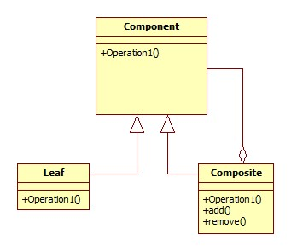

Composite Pattern Implementation
package com.javapapers.designpattern.composite;

public class Block implements Group {

public void assemble() {
System.out.println("Block");
}
}
package com.javapapers.designpattern.composite;

public interface Group {
public void assemble();
}
package com.javapapers.designpattern.composite;

import java.util.ArrayList;
import java.util.List;

public class Structure implements Group {
// Collection of child groups.
private List groups = new ArrayList();

public void assemble() {
for (Group group : groups) {
group.assemble();
}
}

// Adds the group to the structure.
public void add(Group group) {
groups.add(group);
}

// Removes the group from the structure.
public void remove(Group group) {
groups.remove(group);
}
}
package com.javapapers.designpattern.composite;

public class ImplementComposite {
public static void main(String[] args) {
//Initialize three blocks
Block block1 = new Block();
Block block2 = new Block();
Block block3 = new Block();

//Initialize three structure
Structure structure = new Structure();
Structure structure1 = new Structure();
Structure structure2 = new Structure();

//Composes the groups
structure1.add(block1);
structure1.add(block2);

structure2.add(block3);

structure.add(structure1);
structure.add(structure2);

structure.assemble();
}
}

Usage of Composite Design Pattern in Sun/Oracle JDK
- java.awt.Container#add(Component) – in awt, we have containers and components – a classic implementation
- javax.faces.component.UIComponent#getChildren()
This Design Patterns tutorial was added on 13/05/2012.

